CEN Workshop 064 Phase 4
Design and Construction Codes for Gen II to IV nuclear facilities
Kick-off meeting
Date:  2023-06-13 | Doc. Number:  0000

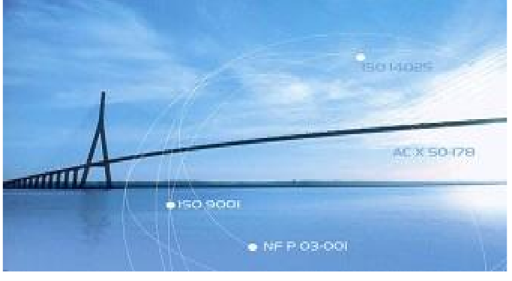

Assistant: | Your contact:
Antoine AUROUSSEAU | Djida LAOUBI
Direct line: +33 (0)1 41 62 84 86 | Direct line: + 33 (0)1 41 62 82 35
antoine.aurousseau@afnor.org | Djida.laoubi@afnor.org

Call for comments for CEN/WS 064/Phase IV kick-off

Comment

Dear all, in preparation for CEN/WS 064/Phase IV “Design and Construction Codes for Gen II to IV nuclear facilities”, you are invited to give your comments on the project plan by filling the document and send it to me by e-mail.

SOURCE
CEN/WS064/Phase 04 Secretariat
E-mail: djida.laoubi@afnor.org

Date: 2023-06-13 | Document: Project Plan | Project:

MB/ NC¹ | Line number  (e.g. 17) | Clause/ Subclause  (e.g. 3.1) | Paragraph/ Figure/ Table/  (e.g. Table 1) | Type of comment² | Comments | Proposed change | Observations of the secretariat

